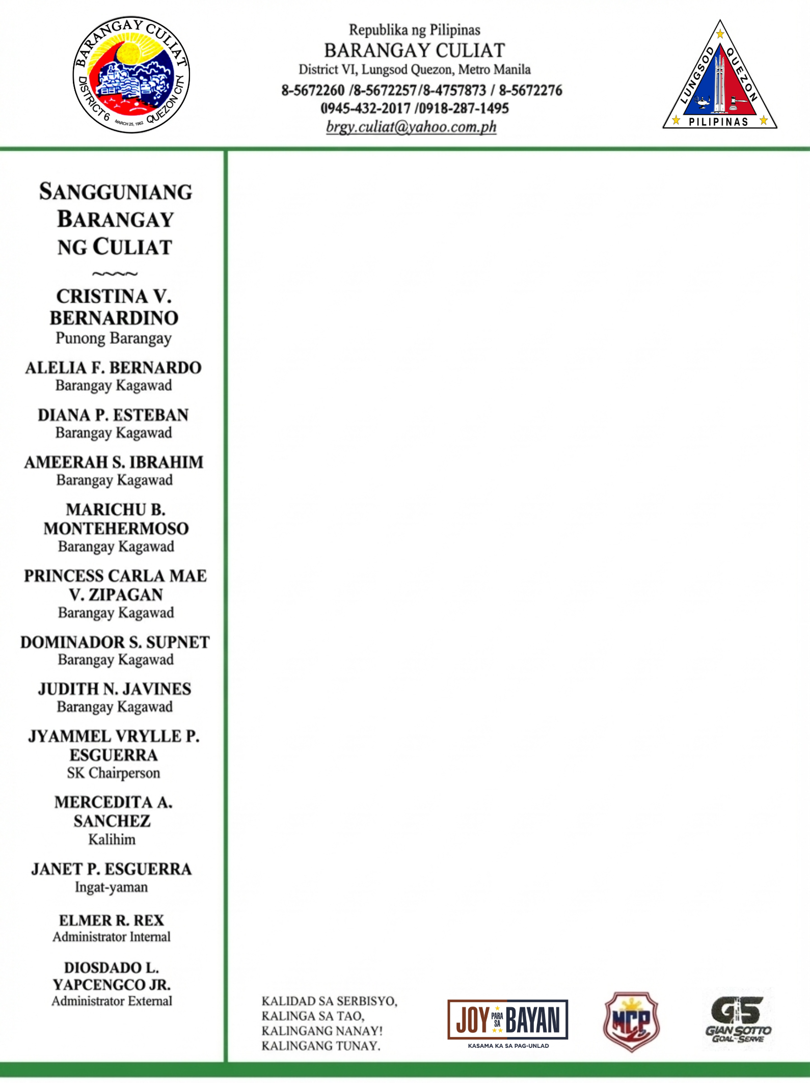

BARANGAY CERTIFICATE

TO WHOM IT MAY CONCERN:

This is to certify that the {business_name}, with registered business address located at {business_full_address}, BRGY. CULIAT QC, has cease its operation in this barangay effective {closure_date}, as per Affidavit of Closure attached herewith.

This certification is issued upon the request of {salutation} {full_name}, Owner of the above-mentioned establishment as requirement for BUSINESS CLOSURE.

Issued this {issue_date} at the office of the Punong Barangay, Barangay Culiat, District VI, Quezon City.

Control No : {control_number}
"This document is online generated at www.barangayculiat.com and is valid without a dry seal. Its authenticity can be verified through the official website using the Control Number provided."

